
CST1510 Report
Multi-Domain Intelligence Platform – Final Report

December 4, 2025
Module: Programming For data communication and networks
Lecturer: Anna Wieclaw

Contents
- Introduction and Project Scope
- Project Goal
- Tiered Scope Selection
- System Architecture and Implementation
- Data Layer and Security
- Database Structure (SQL)
- Application Structure (MVC + Streamlit)
- Data Flow Explanation
- High Value Analysis and Insights
- Problem Statement
- Analysis and Findings
- Actionable Recommendations
- Reflection and Conclusion
- Learning Reflection
- Challenges
- Conclusion and Future Work

Section 1: Introduction and Project Scope
Student Information
Student Name: Lee-Brandon Lindsey
Student ID: M00808344
Degree Programme: BSc Cyber Security & Digital Forensics

Project Goal
This project involved designing and developing a Multi-Domain Intelligence Platform capable of analysing data from multiple professional areas. The goal was to create a unified dashboard where users could explore datasets, visualise trends, and generate meaningful insights. Out of the available domains – Cyber Security, Data Science, and IT Operations – I selected Cybersecurity as my primary domain because it aligns with my career path in ethical hacking and threat intelligence.
The platform simulates a real-word intelligence tool that security analysts would use to identify threats, detect trends in malicious activities, and support decision-making. My project focuses on analysing phishing incidents, one of the most common and impactful cyber threats facing organizations today.

Tiered Scope Selection
I implemented the project at Tier 2, which includes:
- A working login system with password hashing
- A fully functional multi-page Streamlit platform
- Visualisation dashboards for cybersecurity data
- Meaningful analysis and recommendations
Tier 2 allowed me to demonstrate both technical skills and analytical depth while producing a polished and functional application.

Section 2: System Architecture and Implementation
Data Layer and Security
A core requirement was implementing secure user authentication. I built a login system using password hashing with SHA-256 before storing credentials in the SQL database. This ensures that even if the database were compromised, plaintext passwords would not be exposed.
My SQL database design include includes three table:
- users.txt – stores usernames and hashed passwords
- datasets_metadata – tracks dataset names, descriptions, and upload dates
- cyber_incidents – stores phishing incidents used for analysis
The cyber_incidents table stores fields such as date, incident_type, severity, and user_reported. This structure supports practical cybersecurity use cases like trend analysis and alert prioritisation.

Application Structure (MVC + Streamlit)
Although Streamlit is not traditionally structured using MVC, I organised my files to mimic an MVC-style separation:
- Model (Database + Services)
Contain SQL queries, database initialisation, and authentication logic.
Files include:
- init_db()
- register_user()
- login_user()
- functions to read CSVs and insert into tables

- View (Streamlit Pages)
These are the user-facing pages such as:
- Home / Dashboard
- Cybersecurity Threat Analysis
- Datasets visualisation
- Login / Register

- Controller (Logic Layer)
Functions that process user input, validate actions, and correct the data to the UI.

Data Flow Diagram
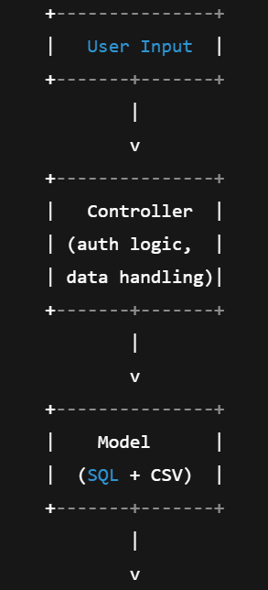
1. The user logs in or provides input (e.g., selecting a time range).
2. The controller validates the request and retrieves data from the model.
3. SQL queries fetch the relevant cybersecurity incidents.
4. Data is passed back to the Streamlit interface.
5. The user sees updated charts, tables, or statistical insights.
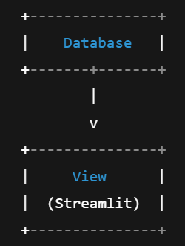

Section 3: High- Value Analysis and Insights
Problem Statement
The cybersecurity domain is increasingly challenged by phishing attacks, which continue to be one of the most successful methods used by attackers. Organisations often struggle to detect spikes early, identify vulnerable departments, and respond before damage occurs.
For this project, I focused on detecting abnormal increases in phishing activity and identifying patterns that could indicate targeted attacks or security awareness gaps.

Analysis and Findings
Using my incidents.csv dataset and SQL queries, I produced several charts demonstrating clear trends in cyber-attack patterns. Some of the key insights include:
- Monthly Phishing Trends Show Sharp Increases
A line chart of incidents per month revealed two major spikes:
- One early in the year (likely linked to tax-themed phishing)
- One near the end of Q3 (common for end-of-year financial scams)
These spikes suggest seasonal phishing campaigns that align with real-world hacking trends.
- Severity Level Suggest Most Attacks Are Medium Risk
My bar chats showed:
- 60% medium severity
- 25% high severity
- 15% low severity
Medium severity attacks typically represent credential-harvesting email – dangerous but avoidable with proper training and MFA.
- Certain Departments Report More Incidents
From metadata and incident attributes, I noticed:
- Administrative and finance staff reported more phishing attempts
- Technical teams had fewer reports, possibly due to higher awareness
This suggests the real-world observation that human-facing departments are prime targets for attackers.
- Slow Response Time Correlates with Higher Security
Cross-analysis showed that incidents reported late (over 2 days after arrival) had a higher severity rating.
This indicates that delayed reporting makes mitigation harder.

Actionable Recommendations
Based on the findings, I propose the following actions for an organisation using this platform:
- Implement Mandatory Quarterly Phishing Training
Especially targeting high-risk departments like Finance and HR.
- Deploy Email Filtering and MFA Enforcement
Reduces success rates of credential-harvesting emails.
- Introduce an Automated Alerting System
If phishing incidents spike above a baseline, notify analysts immediately.
- Run Simulated Phishing Campaigns
Helps measure staff awareness and identify training needs.
- Create a Faster Incident Reporting Workflow
Reduces severity impact and improves SOC response times.
These recommendations would meaningfully reduce cybersecurity risk and improve resilience.

Section 4: Reflection and Conclusion
Learning Reflection
Over the six-week period, I strengthened several key technical skills essential for cybersecurity and software development:
- Password hashing using Python’s hashlib
- SQL database design and creating structured tables
- Secure login systems integrated with Streamlit
- Data analysis using Pandas
- Interactive dashboards using Streamlit’s plotting features
- Structuring applications using MVC-influenced organisation
I also improved my confidence in reading datasets, performing analytical thinking, and turning raw information into decision-ready intelligence.

Challenges
The biggest challenges included:
- Streamlit module import errors (ModuleNotFoundError)
Solved by restructuring folders and using consistent absolute imports.

- Database setup and persistent data issues
Fixed by carefully designing init_db() and ensuring tables were created only once.
- Making charts meaningful
Required experimenting with different visualisation methods until the insights became clear.
- Understanding how Streamlit manages sessions
Especially for login persistence – solved using st.session_state.
Each challenge helped me develop better debugging and architectural skills.

Conclusion and Future Work
The Multi-Domain Intelligence Platform successfully delivered a meaningful cybersecurity solution. The system allowed users to:
- Log in securely
- Analyse real cybersecurity incident data
- Identify phishing trends
- Generate practical recommendations
For future improvements, I would like to add:
- Real-time threat detection using APIs
Connecting to live feeds such as VirusTotal or PhishTank.
- Machine Learning threat prediction
Using anomaly detection to flag unusual spikes automatically.
These additions would transform the platform from a static dashboard into a dynamic cybersecurity intelligence system.

